**South Downs National Park – Viewing Circle**

There are many beautiful things to see in the South Downs National Park, from breath taking views to special habitats to rare plants and animals.

Next time you are out in the South Downs National Park, why not take our viewing circle with you. Using a viewing circle can help to narrow down your point of view, helping you to focus on the smaller details in the landscape. Perhaps you will spot a rare bird such as a sky lark fluttering high into the sky. Or maybe you will spot a tractor trundling over the farmland which makes up 80% of the South Downs National Park.

Take your time, enjoy the view and perhaps even note down the things you seen on the outside of the learning circles.

South Downs National Park

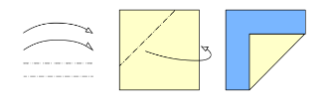



Fold

Image result for cut symbols

Image result for cut symbols