Seven Sisters Special Species Scavenger Hunt
What can you find as your walk or sit in the Seven Sisters Country Park?
The Seven Sisters Country Park offers some of the finest coastal downland views in the whole of the UK. It also contains a wide range of habitats with a fantastic array of associated wildlife.
From the springy turf of chalk downland to the secret underwater world of the beach rock pools, come and explore the wonderful natural world of the Seven Sisters. What will you discover?
Species | Picture | Description | Did you spot it?
Adonis Blue Butterfly | 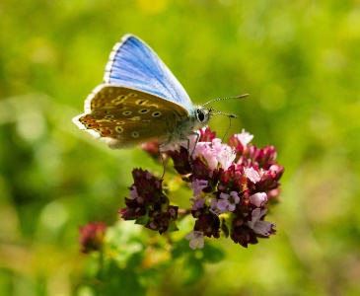 | This brilliant blue butterfly is a very special species on the chalk grassland. When these arrive in August, it shows we have a healthy chalk grassland.
Skylark | 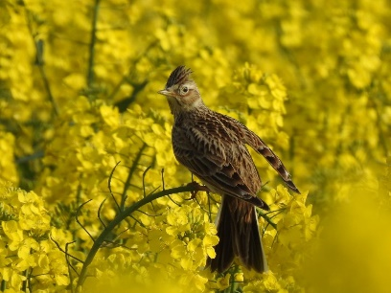 | Listen carefully – can you hear the song of a skylark?  They are even more challenging to spot. The male bird flies as high as 300m where he hovers to sing his scratchy song, before dropping back down to the ground.
Yellow-horned Poppy | 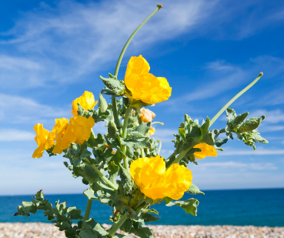 | Walk along the beach and you may glimpse the vibrant, golden flower of the yellow-horned poppy. This plant is tough! It loves the salty sea spray and getting buried in shingle.
Ringed Plover | 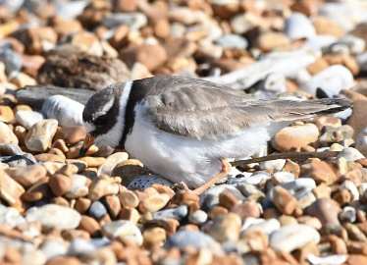 | This tiny bird, wades in the shallows of the sea and likes to lays its camouflaged eggs on the shingle. These are a very rare spot!
Cowslip | 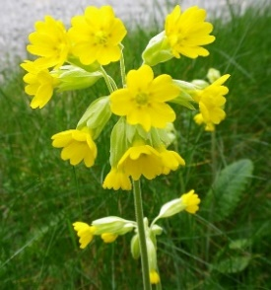 | Called so after the spot it is often found in – meadows and the occasional cow pat! Cowslips are glorious yellow flowers that can be found bobbing in the wind in early spring.
Flint | 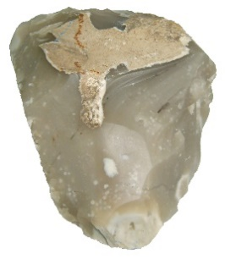 | One of the tougher rocks in the Seven Sisters Country Park, flint is a smooth, glossy stone. During human history, it has helped us start fires, become hunting tools and been used to build houses. Look out near the visitor centre and you might even spot a wall of flint rocks.
Chalk | 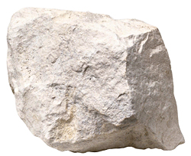 | The chalky cliffs of the Seven Sisters are one of our most famous landmarks. Chalk is a rock formed from the shells of animals over lots of year. It absorbs water and

