South Downs National Park Knowledge Organiser
Key Vocabulary |  | Starting out | Expand on it | Become an expert
Word | Definition | The SDNP was created in 2010 and joined a family of 14 other National Parks and 46 National Landscapes. It is still the youngest and newest National Park in the family.  Yet the landscape was actually created over 20 million years ago when two tectonic plates crashed together. This created Everest, the European Alps and the South Downs ridge all at the same time.  It extends over an area of 1,600km². It is long and thin as it follows a line of chalk hills (called the South Downs) which stretch from Winchester in the west, to Eastbourne in the East, where the hills become cliffs and meet the English Channel. | The SDNP was protected because of seven special qualities:  - Breathtaking views  - Centuries of farming  - Important historical features  - Peaceful places  - Rare plants and animals  - Adventures and learning  - Distinctive towns, villages and communities.  Evidence of every period of human history from the Neolithic to present day can be found within the SDNP boundaries.  The National Park Authority works with hundreds of other organisations to help look after the National Park. Altogether, that’s thousands of staff and volunteers working together to look after this special place | There are six special habitats across the SDNP. We have listed them from largest to smallest area in the SDNP  - Farmland (80%)  - Ancient woodland (23%)  - Rivers and wetlands  - Coastal  - Chalk grassland (4%)  - Lowland heath (1%)  Remember some habitats can be from more than one category so these percentages add up to more than 100%.  In these habitats, you will find rare and unique species such as kingfishers, skylarks, adders, pipistrelle bats, 11 different orchids or 39 different species of butterflies including the Adonis Blue.
Chalk | A white rock formed from the skeletal remains of sea creatures.
Habitat | The natural home or environment of an animal or plant.
National Park | Areas of protected countryside that everyone can visit and enjoy.
National Trail | Long distance footpaths or bridleways in England and Wales.
Rare | When something is not found in large number and so if of interest or value.
Call to Action:
The SDNP is here for everyone to enjoy and is protected so that people and nature can enjoy the park for many years to come. You can do your bit from the park by taking small actions for nature. These might include planting pollinator friendly plants, reducing your plastic usage or recording the wildlife near you. Every little bit helps us work towards our goal of ensuring 33% of the SDNP is managed for Nature by 2030.

What does the SDNP look like?
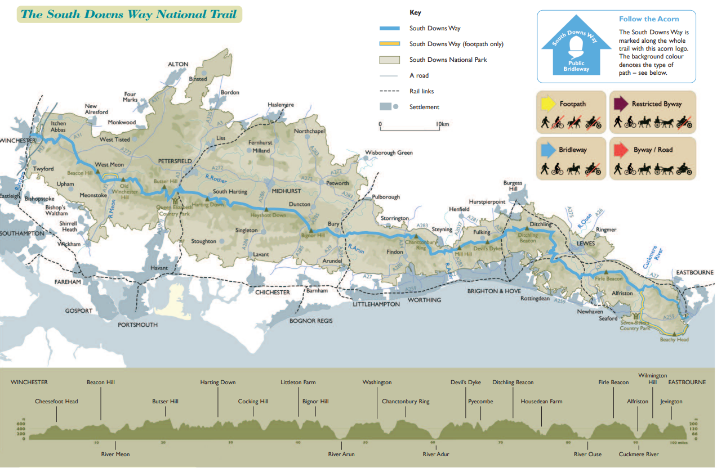
This is a map of the South Downs National Park including the South Downs Way, a national trail that runs from Winchester to Eastbourne which 50,000 people walk, run, cycle or ride along every year. You can also see the topography, which shows how hilly the South Downs National Park really is!

