**Farmland Fact File**

[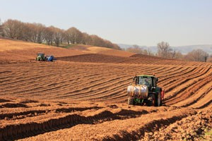](http://learning.southdowns.gov.uk/wp-content/uploads/sites/2/2015/09/Planting-Potatoes.jpg)Farmland includes wildlife habitats such as grassland, arable land and hedgerows. The quality of farmland habitats for wildlife can vary enormously.

Arable cropland is a great place to see some of the UK’s rarest farmland birds. These include corn bunting, grey partridge, skylark and stone curlew. The National Park is also considered to be a national hotspot for rare arable plants. In addition to plants and birds, farmland habitats also support some interesting and special mammals such as harvest mouse and brown hare. Farm hedges and field margins act as ‘wildlife corridors’ for many species including bats.

While the extent of farmland has probably not changed significantly over the past century, the balance of different uses has varied a great deal. Over the last 50–100 years, the quality of many farmland habitats for wildlife has declined dramatically. Increasing intensification of agriculture because of farming subsidies in the latter half of the 20th century had a devastating impact upon many species of wildlife dependent on farmland habitats.

Modern herbicides and seed cleaning methods reduced the presence of arable plants such as rough poppy. Changes in arable cropping practices such as a switch from spring to autumn sown cereals has reduced habitat and food availability for farmland birds and other wildlife.

Proportions of different habitats which make up farmland have also changed in recent history, for example, significant amounts of sheep-grazed chalk downland were ploughed up during and after World War II to grow crops such as wheat and barley, and over the past decade vineyards have increased in number.

A good proportion of farms are on the Environmental Stewardship scheme. This scheme enables farmers and land managers to make a living and also contribute to improving biodiversity and habitats for wildlife. Actions taken often have the added benefit of reducing the need for pesticides by increasing the numbers of natural predators.