**Climate Change – Causes and Natural Solutions**

**Matching Games**

What do you need to prepare?

Cut out the cards and headings below

Activity

1. The three headings explain some of the evidence we have that climate change is impacting our world. These clues result in some damaging outcomes for the local landscape but they can also be resolved by nature based solutions.
2. Can the children match the correct results to the correct heading?
3. Now can the children find the nature-based solution that might offset the impact of climate change?
4. Go through the answers together (found on page 11 of this document)

Headings

Cards

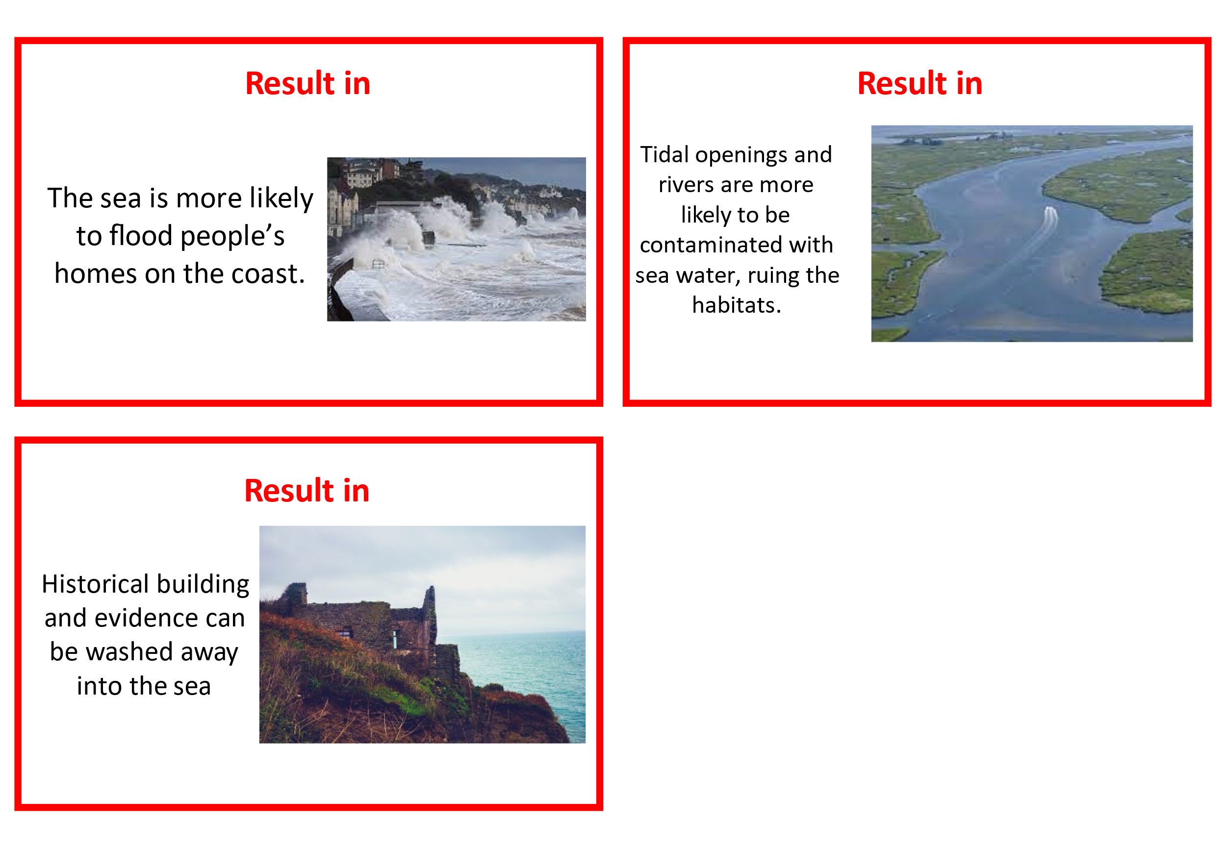 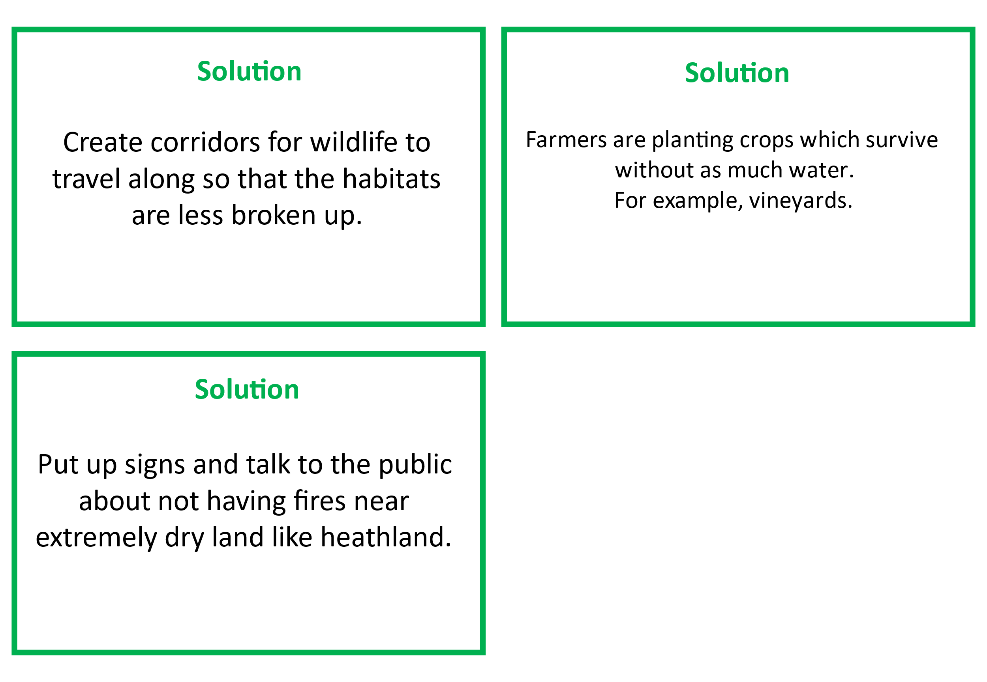 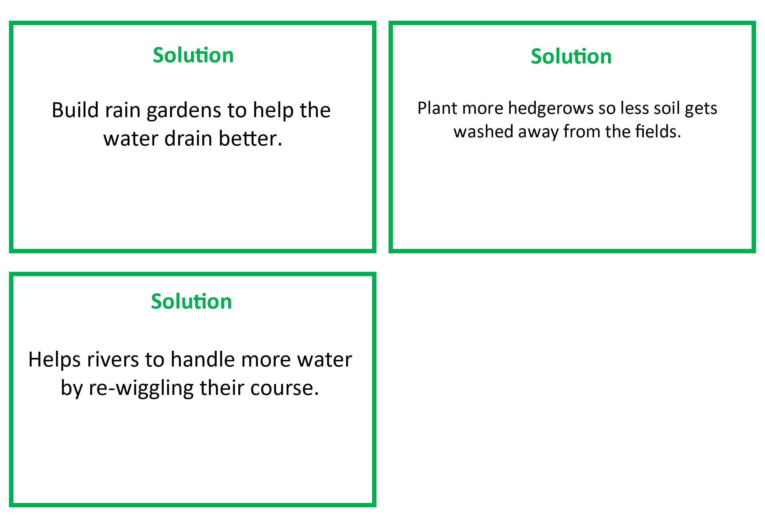 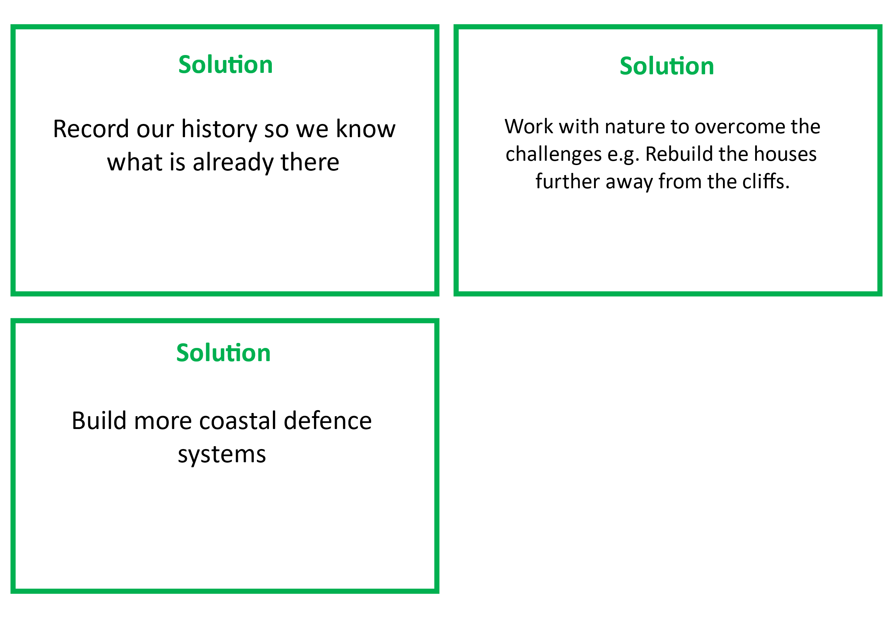

**Answers**

|  |  |  |
| --- | --- | --- |
| **Climate Change** | **Results in** | **Nature based solutions** |
| Rising Sea Levels | The sea is more likely to flood people’s homes on the coast  Tidal openings and rivers are more likely to be contaminated with sea water, ruining habitats.  Historic buildings and evidence close to the coast can be washed away into the sea. | Record out history so we know what is already there.  Work with nature to overcome the challenges e.g. rebuild the house further away from the cliffs.  Build more coastal defence systems. |
| Temperatures getting hotter and the land getting drier | Wildfires on rare heathland sites meaning we lose animals and their homes  Less hedgerows grow which leads to less habitats (homes) for animals likes birds, hedgehogs and bugs.  Chalk grassland plants struggle to grow and survive without water.  Crops which give use food struggle to grow when it is too hot.  Habitats become smaller and separated so it is harder for animals to travel between them. | Create corridors for wildlife to travel along so that the habitats are less broken up.  Farmers are planting crops which survive without much water e.g. vineyards  Put up signs and talk to the public about not having fires near extremely dry land like heathland. |
| More storms and heavy rain | Flooding costs the UK £1.3 billion a year  Heavy rain can cause the soil to get washed away. This stops it being food for plants and stable buildings  Trees are blown down  Historical buildings are damaged. | Build rain gardens to help water drain better  Plant more hedgerows so less soil gets washed away from the fields.  Help rivers to handle more water by re-wiggling their course. |