**Benny Rothman – Trespass Game**

Benny Rothman led a vital member of the Kinder Scout Trespass. This sparked a national discussion about protecting outdoor spaces for all to enjoy. It eventually led to the created of the Peak District National Park and all those that followed.

**Introduce the activity**

Show the photograph of Benny Rothman (page 2), the photographs of Manchester in the 1930s (page 3 and 4) where he lived and worked, and read the quote from Benny (page 5).

Explain that Benny was sent to prison for 6 months in 1932.

*Question - What do the pupils think Benny might have been imprisoned for, given the evidence?*

Encourage discussion and explore with the pupils the word ‘rambler’ and what ramblers do.

Given the urban area in which Benny lived and worked for six days a week, why would spending Sunday out in the open countryside be something he would have looked forward to, especially somewhere like Kinder Scout.

**Activity - Re-enact the trespass**

Identify a high-point, tree, bench, etc. as the plateau of Kinder Scout.

Take one-fifth of the group to act as gamekeepers and police officers. Position the gamekeepers and police officers in a line between the rest of the group (the trespassers) and Kinder Scout.

Identify one pupil to be Benny Rothman. Benny leads the trespassers along a “path” parallel to the police officers and gamekeepers. Help to identify Benny by giving him a jacket or cap to wear!

The rest of the group follow Benny until the agreed signal (whistle, shout, clap of hands, etc), at which point they make a break for Kinder Scout, and must avoid getting tagged by the police officers and gamekeepers.

**Discussion**

Encourage discussion and explore with pupils how it would have felt to be a trespasser. Why would they have risked going to prison? Explore how it would have felt to be a police officer or gamekeeper. Why did they want to stop people from accessing Kinder Scout?

Explain what happened as a result of the trespass.

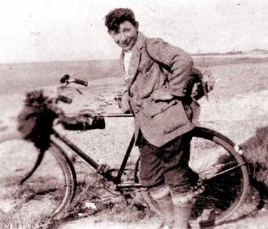

Benny Rothman

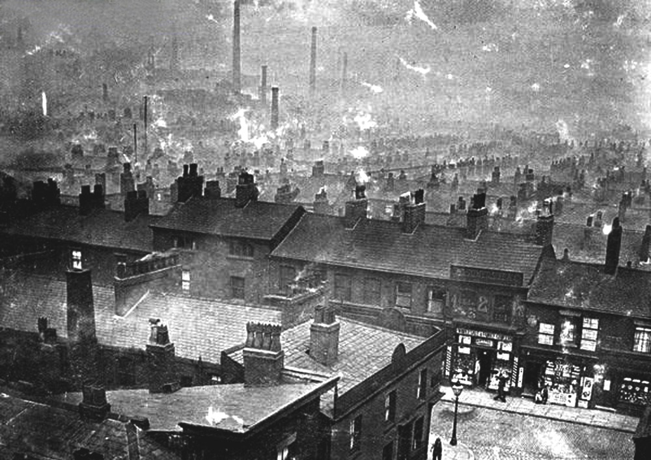

**Manchester, 1930’s**

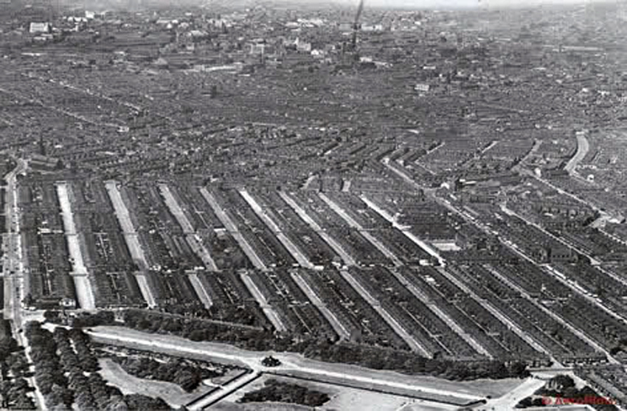

**Manchester, 1930’s**

**‘We ramblers, after a hard week’s work in smoky towns and cities, go out rambling for relaxation, a breath of fresh air, a little sunshine. And we find when we go out that the finest rambling country is closed to us.’**

**Benny Rothman, 1932**

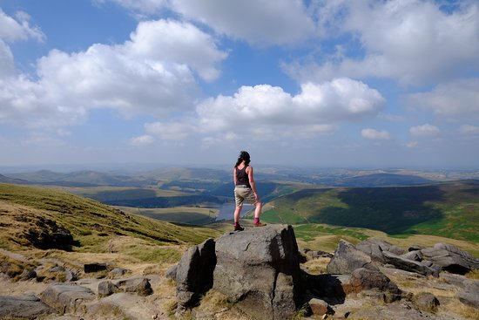

Kinder Scout

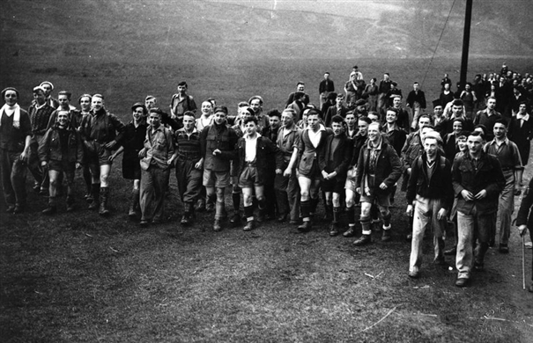

*‘On Sunday, April 24, 1932, a group of mainly young people from the Manchester and Sheffield areas set out to climb to the top of Kinder Scout, in the Derbyshire Peak District. In those days, walkers had to keep to the footpaths, which usually didn’t go to the tops of hills. When news of the planned trespass got out, gamekeepers and police were out in force to stop them. The ramblers changed the site of their starting point to a disused quarry. They then set out along the footpath at the foot of the hill. At a signal from a whistle, they broke from the path and rushed for the top. Six of them were arrested, tried and put in prison. One of them, Benny Rothman, got 6 months’.* – Fay Sampson