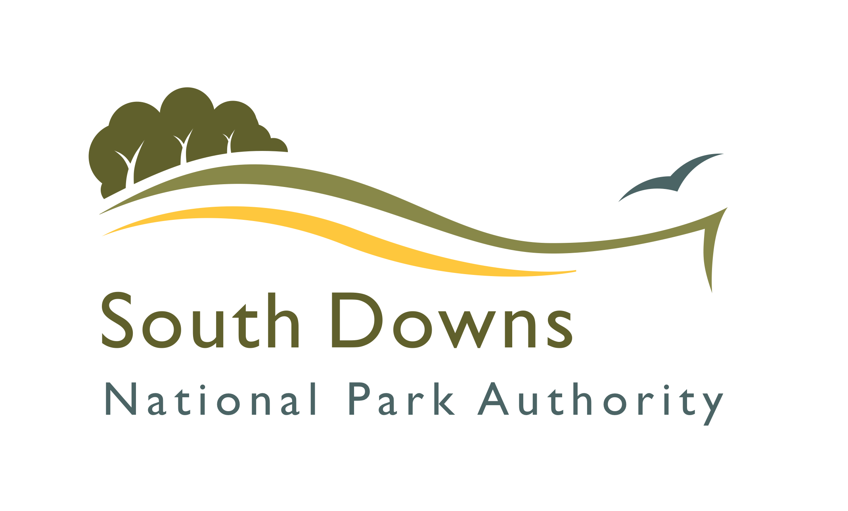 | South Downs National Park Authority  Strategic Housing Land Availability Assessment  Site Submission and Update Form

This form should be used to submit or update previous information on potential residential land to the South Downs National Park Authority for consideration in the Strategic Housing Land Availability Assessment (SHLAA) process.
The first SHLAA for South Downs National Park was published in January 2015. This assessed sites submitted to us before 31st October 2014. The SHLAA will be updated on a regular basis, through the Authority Monitoring Report or update reports, as required.

We continue to invite site submissions for consideration in future assessments.

The deadline for sites to be considered in the next update of the SHLAA is
28th October 2015.

More information on the SHLAA is available at http://www.southdowns.gov.uk/shlaa

- Please complete as many parts of the form as possible.
- A map is required at a suitable scale, showing the boundary of the site accurately.

Your Details
Name
Organisation (if applicable)
On behalf of (if applicable)
Your Status | Landowner:  Agent:  Consultant:  Developer:  Other (please state):
Your Address
Telephone No.
Email

Site Details
Site Address / Location
Has this site previously been submitted as a SHLAA site? If yes, please provide the site name and site reference number (if known).
Site Area (hectares)
Is the site previously developed land? | Yes  No
What is the current use of the site?
To your knowledge, has the land been subject to any planning applications in the last 3 years?  If yes, please provide details and application references. | Yes  No

Site Development Proposal
How many dwellings would you envisage on the site?
What type of dwellings would you envisage? (houses, flats etc)
Would the proposal be 100% Affordable Housing?

Ownership
Are you the landowner? | Yes  No
If no, please name the owner or state if the owner is unknown.

If you are not the owner please explain your interest in the land.
Are you the sole or part owner of the land? | Sole owner  Part owner
If you are a part owner, please name the other owners.

Availability
When is the site available for potential development? | 1 – 5 years:  6 – 10 years:  11+ years:
Are there any constraints to availability that will delay delivery?

Possible Constraints to Development
Please consider the following potential issues and advise if you are aware of any that relate to the submitted site and, if possible, outline what could be done to overcome these constraints.
Access difficulties (lack of road frontage or physical obstructions)
Topography or ground conditions (steep slopes etc)
Flooding & Drainage issues
Legal Issues / Covenants (ransom strips, multiple ownership)
Infrastructure deficiencies
Contamination / hazards
Other

Additional information
Please outline why you consider the site is suitable for housing:
Please provide any additional information which may assist in the site assessment:

Officer Site Visit
A planning officer may require access to the site to undertake an assessment for the SHLAA. This site visit does not need to be accompanied by the landowner unless you request here:
Contact details (if necessary) to arrange a site visit:
Are there any obstacles to gaining access on a site visit?

DISCLAIMER
The assessment process or final results of this Strategic Housing Land Availability Assessment does not allocate sites for development. In seeking the submission of sites for development, the National Park Authority is making no commitment in respect of which sites will be allocated. The allocation of sites will be determined through either the South Downs National Park Local Plan or neighbourhood development plans. The identification of potential sites within the Strategic Housing Land Availability Assessment does not imply that planning permission would be granted.

DATA PROTECTION STATEMENT
The information collected in this response form will be used by the National Park Authority to inform the Strategic Housing Land Availability Assessment and subsequent components of the Local Plan. By responding you are accepting that your response and the information within it (except for personal information) may be made available to the public.

Please return this form to:

planningpolicy@southdowns.gov.uk

or

SHLAA
Planning Policy Team
South Downs National Park Authority
South Downs Centre
North Street
Midhurst
West Sussex
GU29 9DH

For further information, please see the SHLAA webpage at: http://www.southdowns.gov.uk/shlaa

