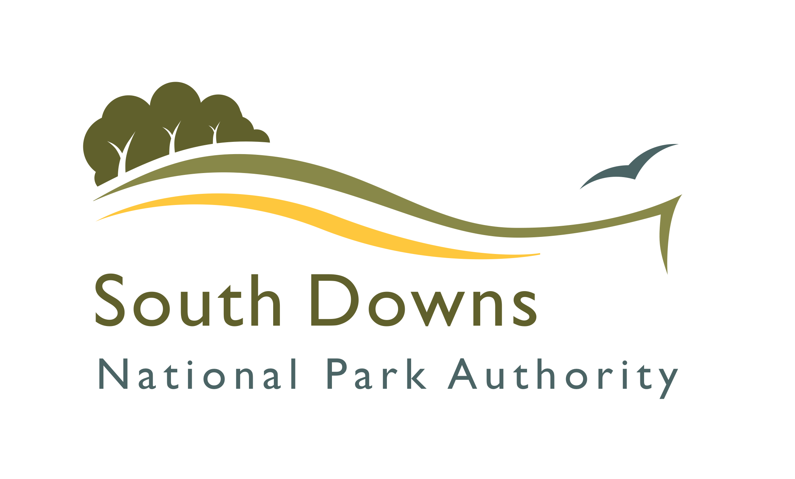
South Downs National Park Authority
Strategic Housing Land Availability Assessment

Site Submission Form

This form should be used to submit potential residential land to the South Downs National Park Authority for consideration in the Strategic Housing Land Availability Assessment (SHLAA) process.

- Please complete as many parts of the form as possible.
- Your name and address are required although will only be used to contact you for any further details, if necessary.
- A map is required at a suitable scale, showing the boundary of the site accurately.
- Please return this form to planningpolicy@southdowns.gov.uk or the following postal address:

SHLAA
Planning Policy Team
South Downs National Park Authority
Rosemary’s Parlour
Midhurst
West Sussex
GU29 9SB

Your Details
Name
Organisation (if applicable)
On behalf of (if applicable)
Your Status | Landowner:  Agent:  Consultant:  Developer:  Other (please state):
Your Address
Telephone No.
Email

Site Details
Site Address / Location
Site Area (hectares)
OS Grid Reference
Current Use
Planning Permissions / History

Site Development Proposal
How many dwellings would you envisage on the site?
What type of dwellings would you envisage? (houses, flats etc)
Would the proposal be 100% Affordable Housing?

Ownership
Are you the landowner?
If “Yes”, are there joint-owners?
If “No”, who is the landowner?

Availability
When is the site available for potential development? | 1 – 5 years:  6 – 10 years:  11+ years:
Are they are constraints to availability that will delay delivery?

Possible Constraints to Development
Please consider the following potential issues and advise if you are aware of any that relate to the submitted site and, if possible, outline what could be done to overcome these constraints.
Access difficulties (lack of road frontage or physical obstructions)
Topography or ground conditions (steep slopes etc)
Flooding & Drainage issues
Legal Issues / Covenants (ransom strips, multiple ownership)
Infrastructure deficiencies
Contamination / hazards
Other

Additional information
Please outline why you consider the site is suitable for housing:
Please provide any additional information which may assist in the site assessment:

Officer Site Visit
A planning officer may require access to the site to undertake an assessment for the SHLAA. This site visit does not need to be accompanied by the landowner unless you request here:
Contact details (if necessary) to arrange a site visit:
Are there any obstacles to gaining access on a site visit?

Please return this form to:

planningpolicy@southdowns.gov.uk

or

SHLAA
Planning Policy Team
South Downs National Park Authority
Rosemary’s Parlour
Midhurst
West Sussex
GU29 9SB

For further information, please see the SHLAA webpage at: http://www.southdowns.gov.uk/shlaa

DATA PROTECTION STATEMENT

The information collected in this response form will be used by the Park Authority to inform the Strategic Housing Land Availability Assessment and subsequent components of the Local Plan. By responding you are accepting that your response and the information within it may be made available to the public.

