**John Muir – Who was he?**

Get students to think about who John Muir was and the things he did in life.

John Muir was a Scottish American naturalist, author, environmental philosopher and an early advocate of the preservation of wilderness. He fought to protect wild places for both wildlife and as places where people could go for rest and inspiration. He opposed exploitation of natural resources and was instrumental in bringing about legislation that now forms the basis of protected landscapes around the world.

Task

This game enables students to discover some of the key facts about John Muir and his life. There are a number of ways to use the cards with both groups or as individuals.

**In a group**Give out two cards to each person or pair. Go to each person and ask them to read out their fact and decide whether they think it is true or false. Listen to one card from each until all have read one out. Reveal that they are all true. Continue to read the cards out to discover more about John Muir. Ask the group about any they found surprising.

Alternatively, once you have learnt more about John Muir’s life, ask the children to organise themselves into the order in which the events took place. You can find the timeline of John Muir’s life as well as other fantastic resources on the [John Muir website](https://www.johnmuirtrust.org/about-us/about-john-muir).

The facts can provide stimulus for further investigation or research.

**Out and about**Place the facts cards along the length of a walk. The group can be given a map with their locations or simply use their observation skills to find them

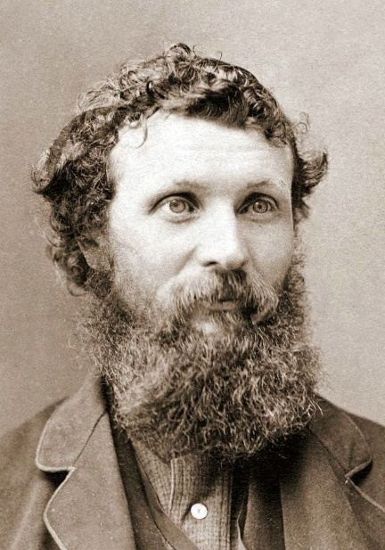[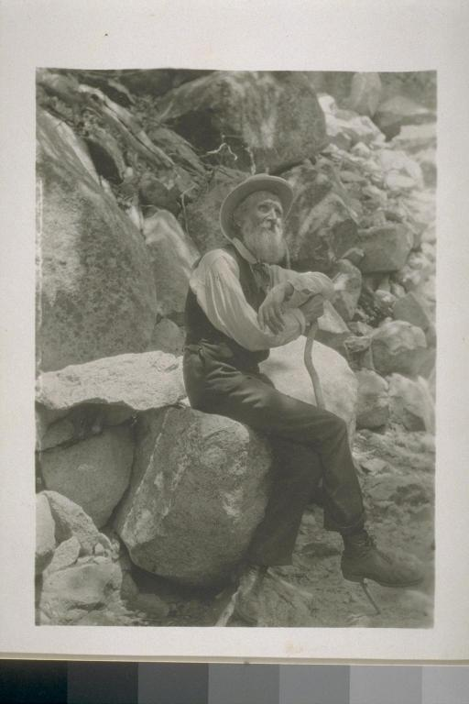

|  |  |
| --- | --- |
| **True or False**  John Muir was a naughty boy who didn’t listen at school | **True or False**  John Muir was a Scotsman who spent his childhood in Dunbar |
| **True or False**  John Muir was an adventurous lad who dared his friend to jump waves and climb on the roof | **True or False**  John Muir was a father of two daughters |
| **True or False**  John Muir was an inventor who created a “get out of bed machine” | **True or False**  John Muir was a loyal and dedicated husband |
| **True or False**  John Muir was the “father of National Parks” | **True or False**  John Muir was the third child in a family of eight children |
| **True or False**  John Muir was a nature writer who influenced politicians and presidents | **True or False**  John Muir was a collector of bird’s eggs |
| **True or False**  John Muir was a restless spirit. | **True or False**  John Muir was an immigrant to the United States |
| **True or False**  John Muir was a fruit farmer | **True or False**  John Muir went to the university of Wisconsin-Madison but didn’t graduate |
| **True or False**  John Muir was a worker at a sawmill factory | **True or False**  John Muir was a supervisor at a wagon wheel factory earning $25 a week |
| **True or False**  John Muir was blind for 6 weeks in March 1867 | **True or False**  John Muir wandered over 1,000 miles |
| **True or False**  John Muir was an officer in the United States Coast Survey | **True or False**  John Muir suffered with malaria – it nearly killed him |
| **True or False**  John Muir was a shepherd | **True or False**  John Muir was a climber |
| **True or False**  Jonh Muir was a fan of naturalist Ralph Waldo Emerson | **True or False**  John Muir was a geologist with a special interest in glaciers |
| **True or False**  John Muri was a cofounder of the Sierra Club – a local alpine club for mountain lovers | **True or False**  John Muir was the president of the Sierra Club for 22 years |
| **True or False**  John Muir didn’t find writing easy | **True or False**  John Muir was a published writer of 300 articles and 12 books |
| **True or False**  John Muir was a maker of clocks | **True or False**  John Muir was a world traveller: Australia, South America, Africa, Europe, China, Japan, America, UK |
| **True or False**  John Muir was a campaigner for the protection of wild places | **True or False**  John Muir was a botanist with a deep interest in plants – inspired from a young age |